Software Solution Testing Document

Ivy Tech Community College

Blue team – SDEV 265 – Fall 2025

October 15th 2025

Last revised : October 16th 2025

# Main Launcher (tkinter GUI)

### Objectives:

* **Display App Title** prominently at the top of the launcher.
* **Showcase each game** with custom cover-art buttons for visual appeal and intuitive selection.
* Include **“Coming Soon” placeholders** for future games and as a fallback for time constraints.
* Add an **About button** to highlight the app’s purpose and development team.
* Ensure each game **launches in a separate window**, while the main launcher **hides during gameplay**.
* When a game is closed, the **launcher reappears seamlessly**, resuming its original position.

### Testing:

**Initial start up:**

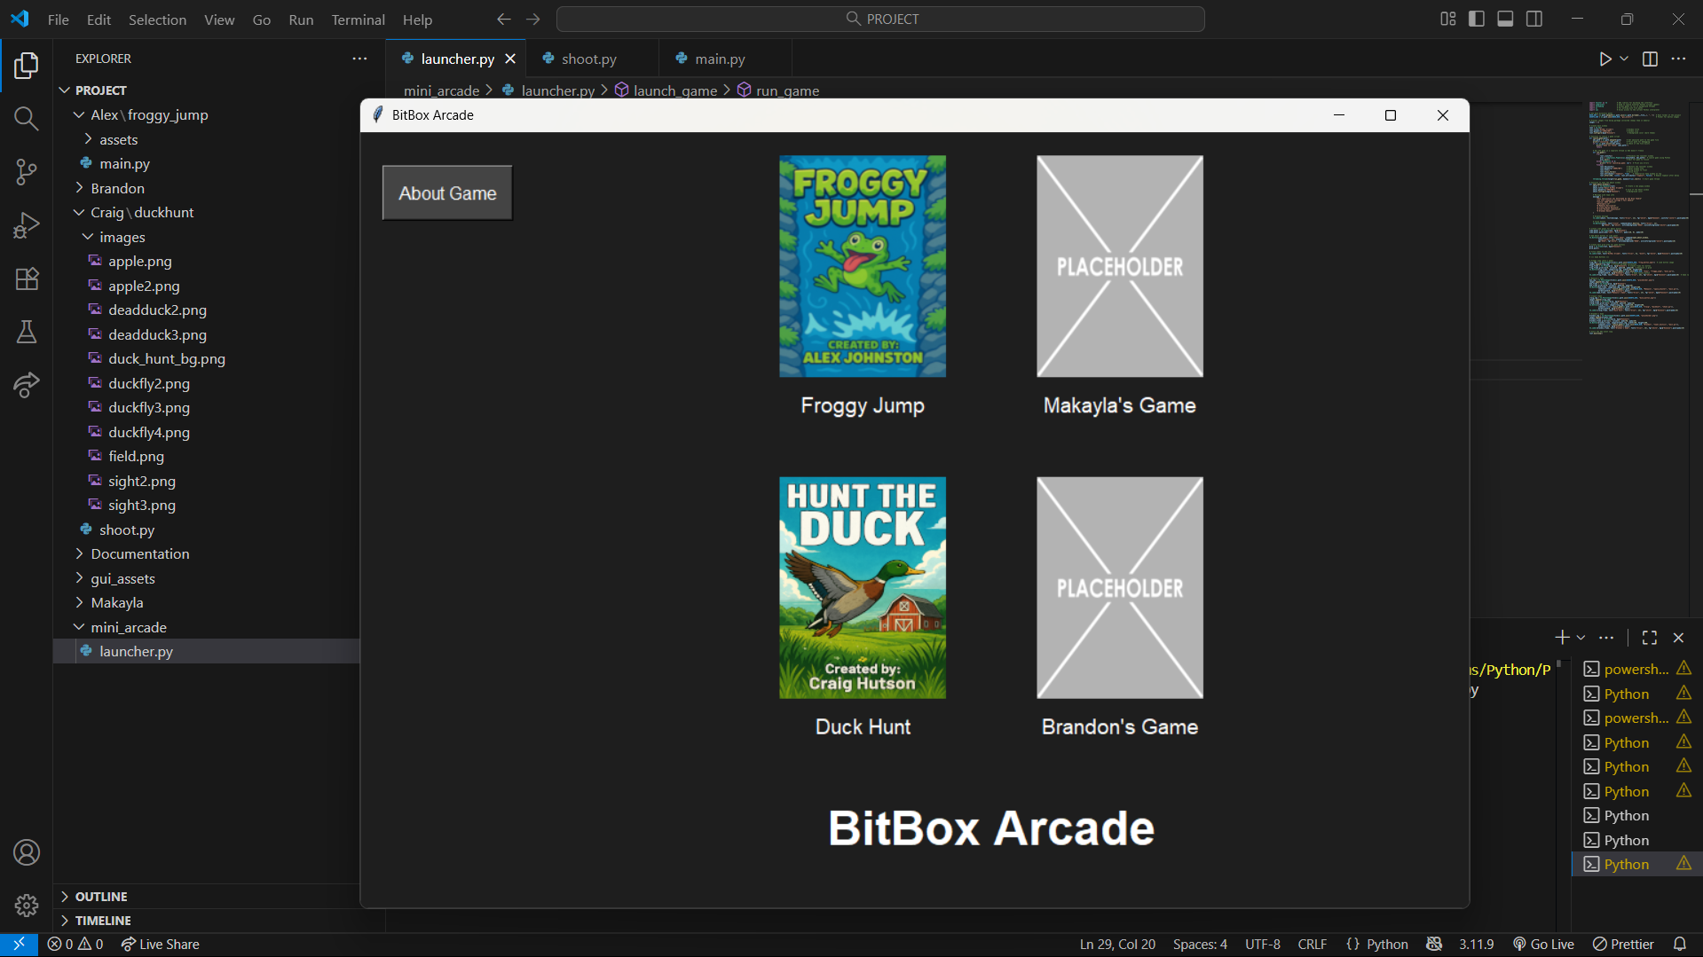

**Clicking about game:**

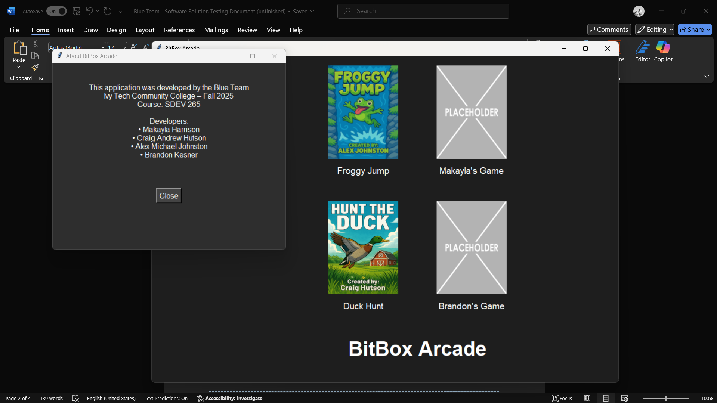

**Clicking Froggy Jump:**

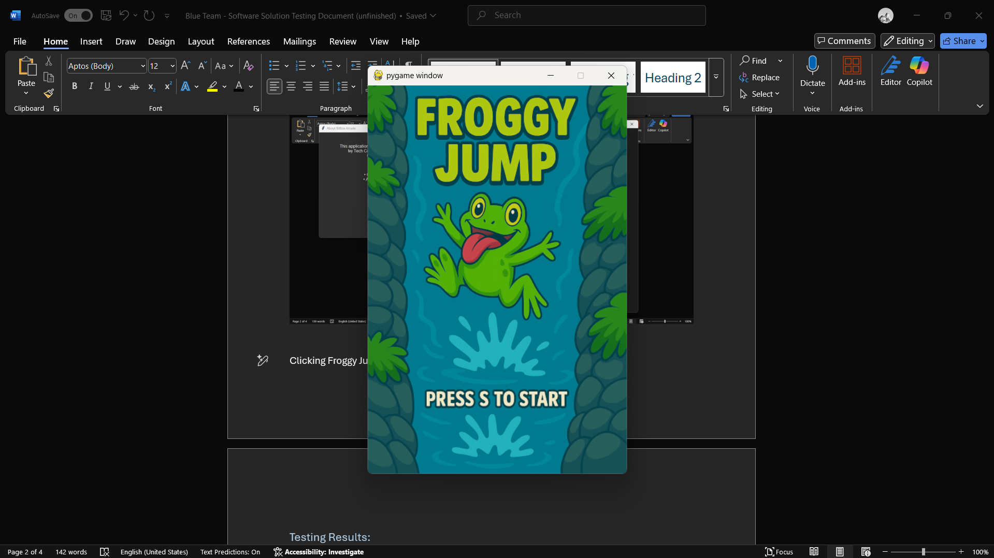

**Closing froggy jump:**

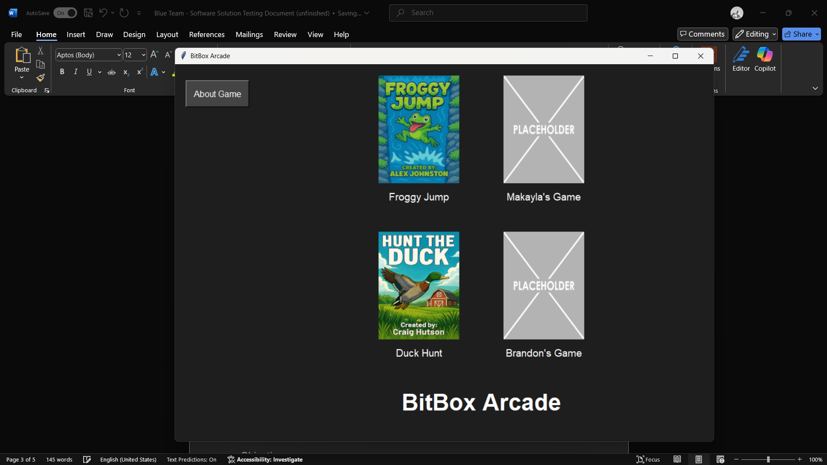

**Opening Hunt The duck:**

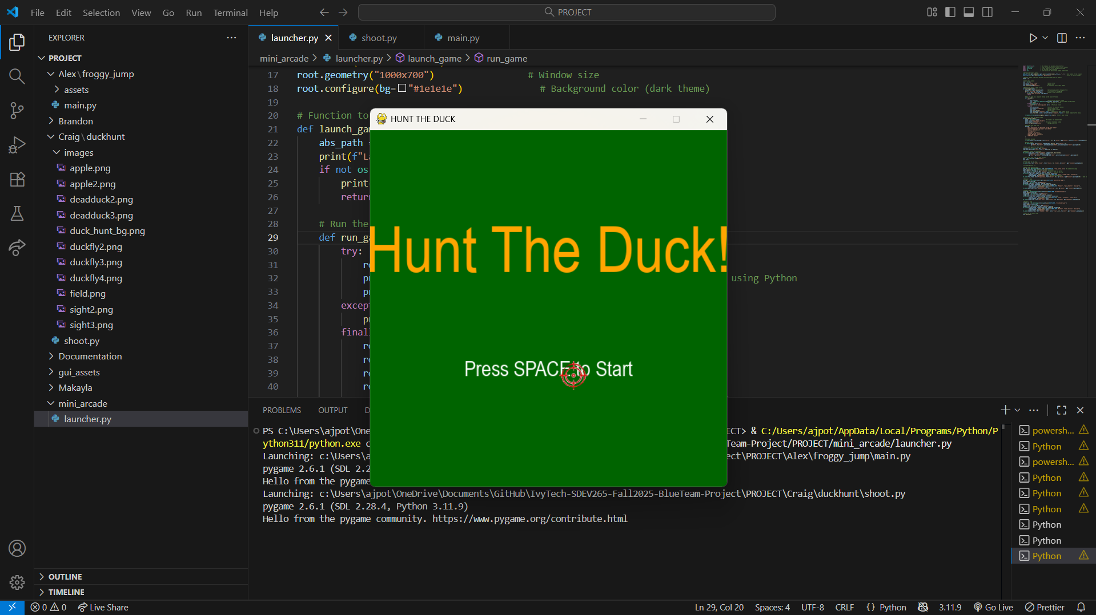

**Closing Hunt The Duck:**

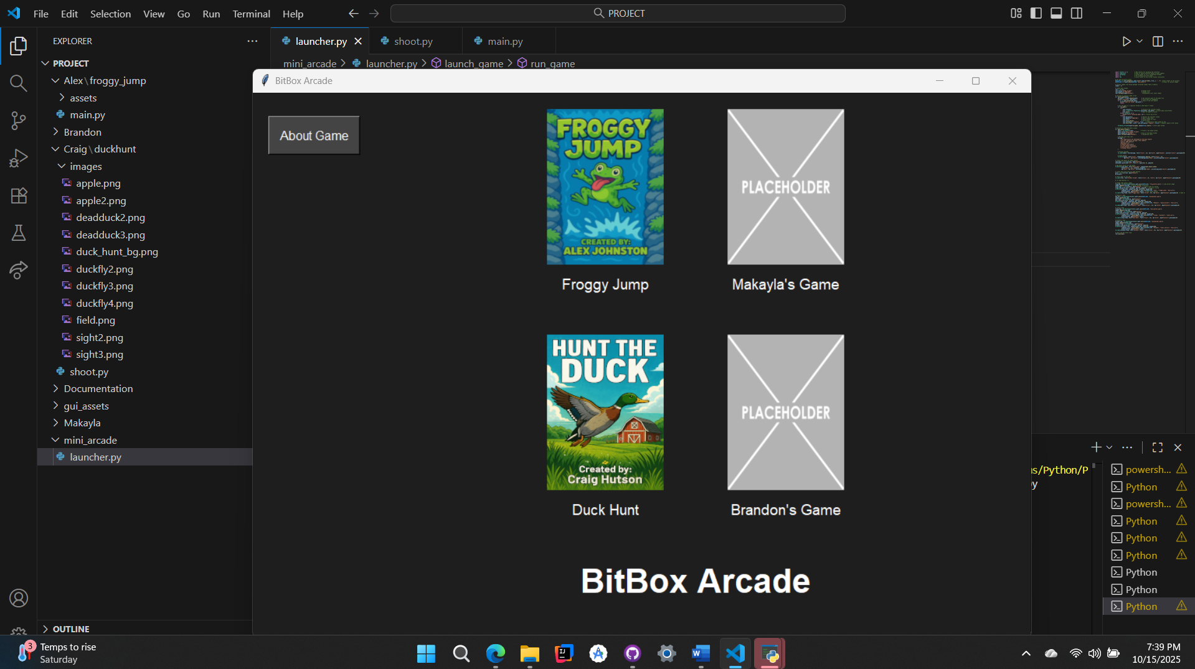

**Opening David and Goliath:**

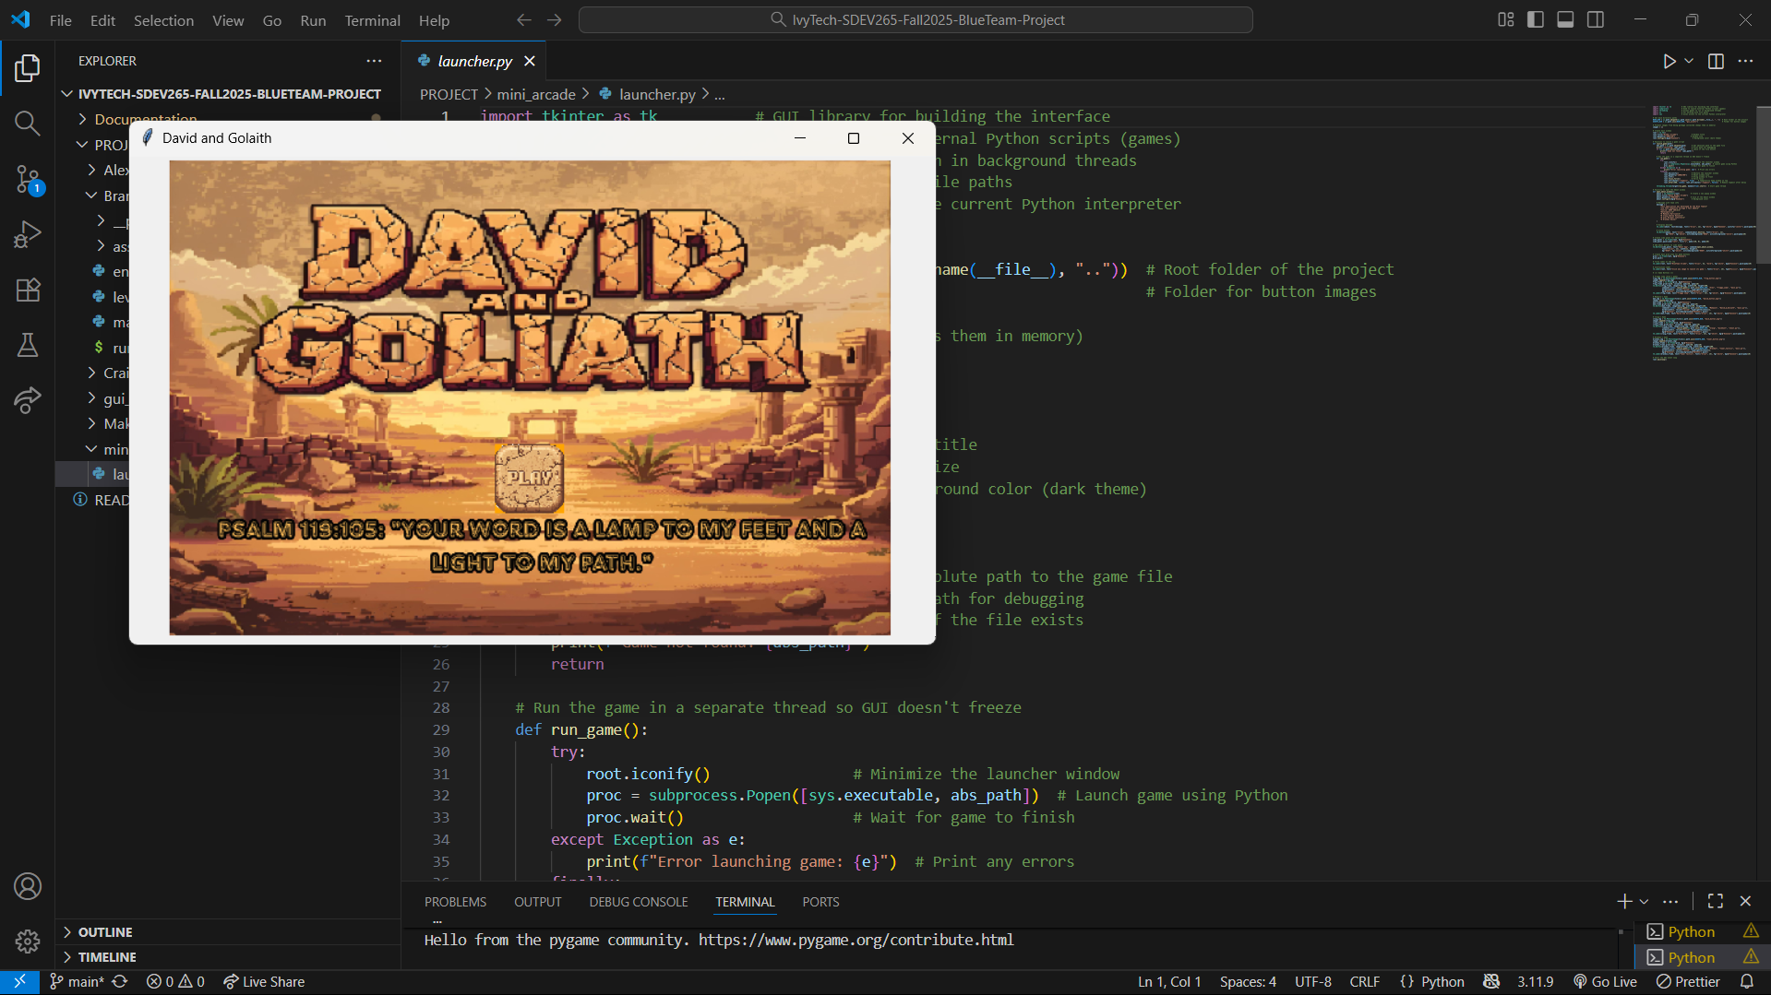

**Closing David and Goliath:**

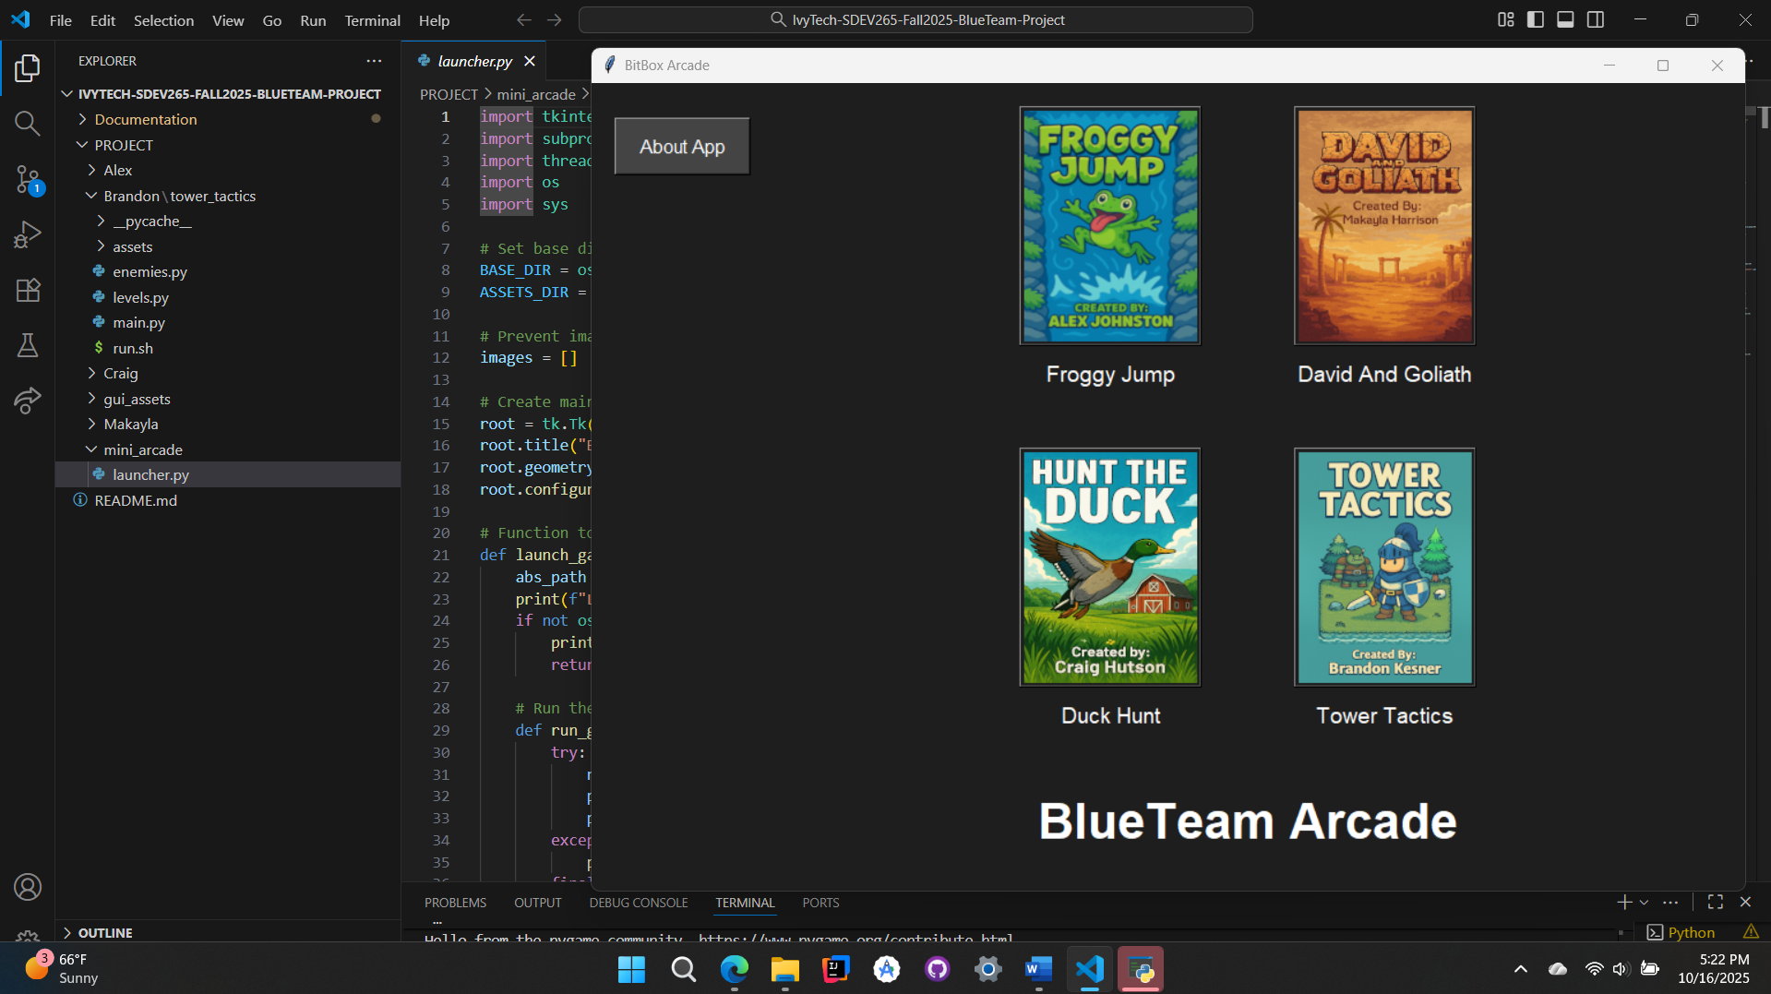

**Opening Tower Defense:**

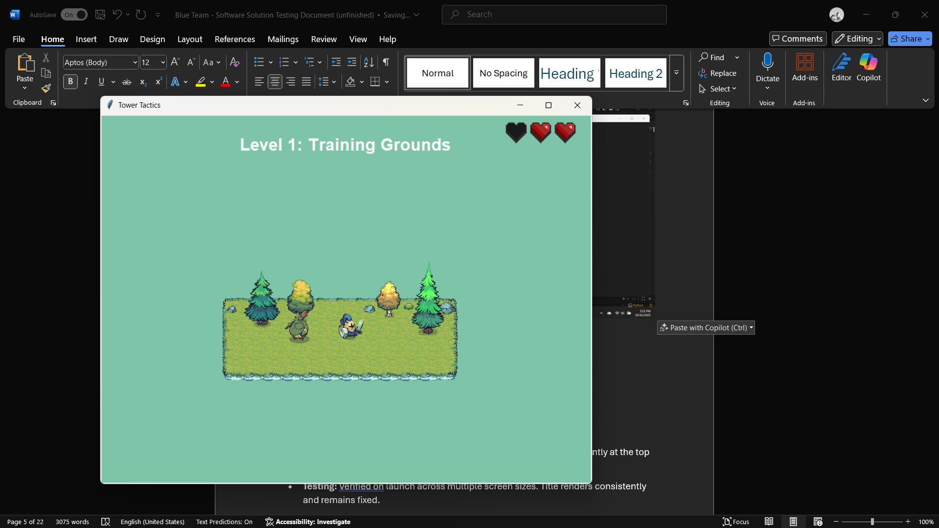

**Closing Tower Defense:**

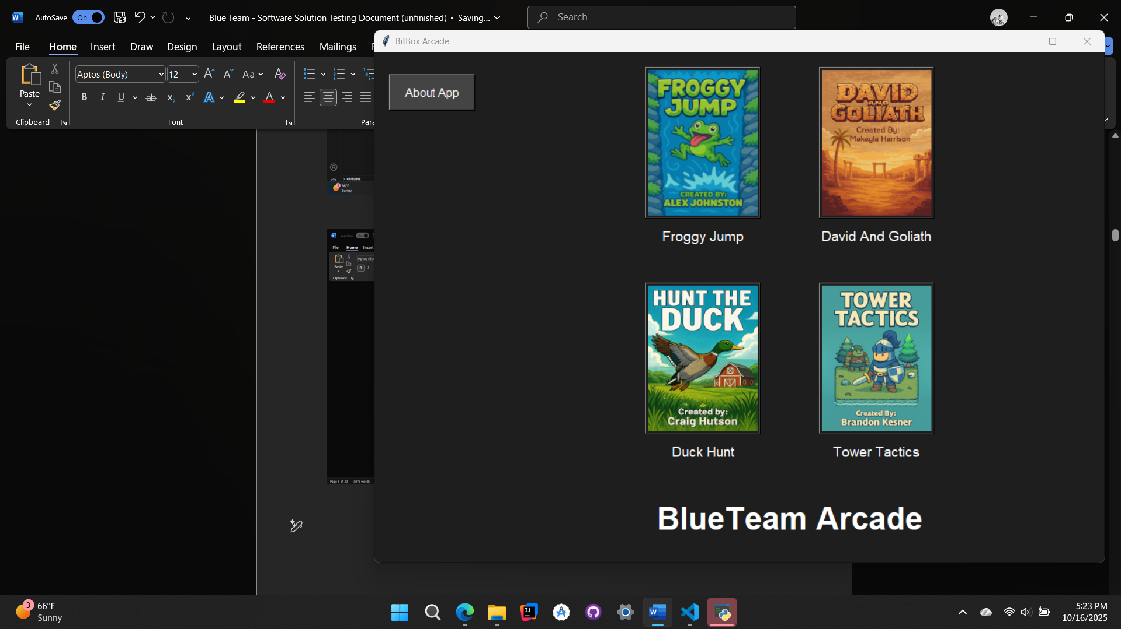

### Testing Results:

**1. App Title Display**

* **Implementation:** The launcher displays the application title prominently at the top using a styled Label widget.
* **Testing:** Verified on launch across multiple screen sizes. Title renders consistently and remains fixed.
* **Result:** Success. Title is clear, centered, and visually distinct.

**2. Custom Cover-Art Buttons for Each Game**

* **Implementation:** Each game is represented by a unique button featuring its cover art, using PhotoImage and Button widgets.
* **Testing:** Clicked each button to confirm image loads correctly and triggers the associated game.
* **Result:** Success. All cover-art buttons are responsive and visually accurate.

**3. “Coming Soon” Placeholder Buttons**

* **Implementation:** Placeholder buttons labeled “Coming Soon” are styled to match the launcher theme and disabled to prevent interaction.
* **Testing:** Verified visual consistency and confirmed they do not trigger any action when clicked.
* **Result:** Success. Placeholders are functional and serve as clear visual cues for future content.

**4. About Button**

* **Implementation:** Added an “About” button that opens a pop-up window with app purpose and developer info.
* **Testing:** Clicked to open and close the pop-up. Confirmed content loads correctly and window closes cleanly.
* **Result:** Success. About section is informative and stable across launches.

**5. Game Launch in Separate Window + Launcher Hide**

* **Implementation:** Each game launches in its own Toplevel() window. The main launcher uses .withdraw() to hide during gameplay.
* **Testing:** Launched each game individually:
  + **Duck Hunt:** Launcher hides, game opens fullscreen, no residual launcher window.
  + **Froggy Jump**: Launcher hides, game opens fullscreen, no residual launcher window.
  + **David and Goliath:** Launcher hides, game opens fullscreen, no residual launcher window.
  + **Tower Defense:** Launcher hides, game opens fullscreen, no residual launcher window.
* **Result:** Success. Launcher hides cleanly for all games.

**6. Launcher Reappears After Game Exit**

* **Implementation:** On game window close, the launcher uses .deiconify() to return to its original position.
* **Testing:** Closed each game manually and via in-game exit buttons:
  + Launcher reappears in correct position and state.
  + No duplicate windows or focus issues.
* **Result:** Success. Launcher resumes seamlessly after each game session.

### --------------------------------------------------------------------------------------------------

# Froggy Jump

### Objectives:

* Create/implement Background
* Create/implement a random appearing platform(s) for the player to scale
* Create/implement a player character
* Create/Implement player character animations that change based on physics
* Create/implement a lower border to end the game
* Create/implement an enemy sprite with collision physics directed to the player sprite.
* Create/implement player physics
* Create/implement random generation of platforms
* Create/implement random generation of enemy sprites
  + Specifically on platforms only
  + For fun, spiders have 2 sprites, one is inverted, every 2 to 5 seconds they switch photos, making the spider appear more alive and not so static.
* Create/ implement sounds upon :
  + Collision with enemy
  + Jump
  + Die
* Create/implement background music
* Create implement a start screen
* Create implement player controls
* Create implement death scenes
  + For fun, 13 different death scenes was implemented that is to display randomly thru an array, so more can easily be added later.
  + This gives a creative way of replayability.
* Create/implement a scoring system

### Testing:

**Initial launch:**

(Background music is instantly heard.)

# **Pressing the S Key:**

**Current Behavior:**

* Pressing the **S key** from the start menu immediately launches the game without any intermediary screens.
* There is **no loading screen** or **control/instruction overlay**, which may cause momentary confusion for first-time players unfamiliar with the controls.
* **Background music** begins automatically and plays continuously, even before gameplay starts.

**User Experience Note:**

* While the instant launch is snappy, the lack of a brief transition or control guide could be disorienting. A simple pre-launch screen showing key bindings and gameplay tips would improve onboarding and polish.

**Minimized Runtime Stability**

**Technical Highlight:**

* When the game is **minimized**, it enters a passive state:
  + **Background music continues playing** without interruption.
  + **Game logic and rendering freeze**, preventing unintended behavior or resource drain.
  + The game remains stable and non-intrusive, allowing full use of the PC—including typing, browsing, or multitasking—without any performance conflict.

**Result:** This behavior is a subtle but impressive technical win. It ensures that the game remains lightweight and non-disruptive when minimized, preserving user control and system responsiveness. It’s a great example of thoughtful design that enhances user comfort and multitasking flexibility.

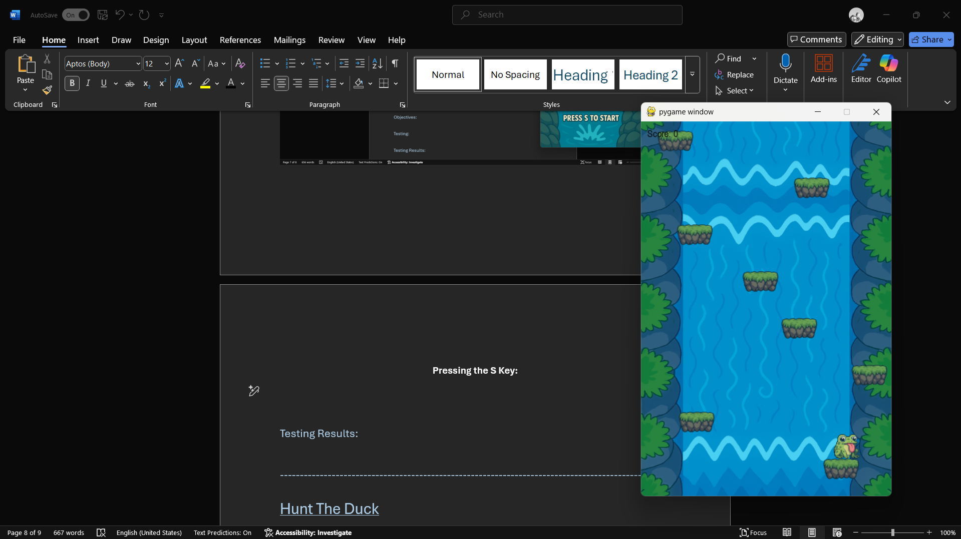

# Testing Game Loop:

**Animation & Physics**

* **Player animations** respond fluidly to gravity-based physics, transitioning seamlessly between idle, jump, and fall states.
* **Jump mechanics** are tightly synced with sound effects, ensuring audio feedback is clean and responsive.
* **Player physics** are precisely tuned: each jump propels the player upward while the platform they launched from scrolls below the screen edge.
  + This intentional design prevents repeated jumps on the same platform, encouraging upward momentum and strategic scaling.
  + It’s a subtle but powerful mechanic that enhances challenge and replayability—brilliantly executed.

**Platform & Enemy Generation**

* **Platforms** spawn randomly and consistently, with no overlap, clipping, or spawn bugs observed during extended playtesting.
* **Spider enemies** generate exclusively on platforms, as designed, with flawless collision behavior and sprite switching every 2–5 seconds for added realism.
* No spawn glitches, stacking errors, or collision misfires were detected—enemy logic is stable and engaging.

**Scoring System**

* Score tracking is fully operational, incrementing accurately based on player progress.
* No desync or reset issues observed during multiple test runs.

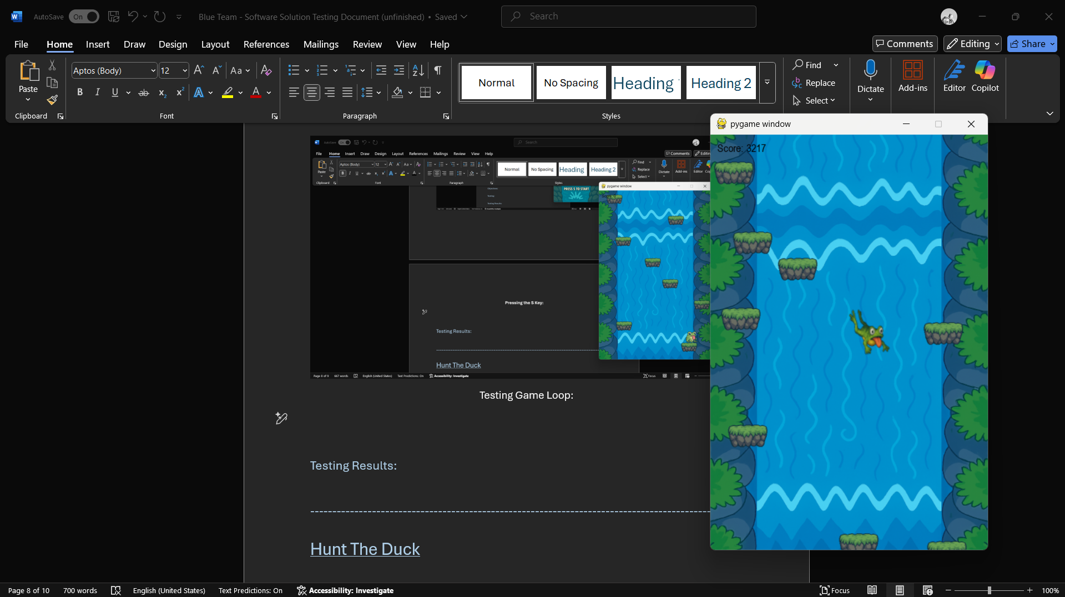

# Testing Collision with Enemy Sprite:

**Froggy Jump – Collision Behavior & Audio Overlap Issue**

**Observation:** During testing, an audio overlap was detected when the player collided with a spider from below while ascending. The collision triggered multiple sound instances in rapid succession, resulting in a distorted or “wonky” effect.

**Cause:** This behavior appears to stem from multiple collision detections occurring within a short timeframe, likely due to the player’s upward momentum intersecting the spider’s hitbox across several frames.

**Resolution Plan:** To ensure clean collision handling and prevent repeated sound triggers:

* Implement a **single-collision flag** for the player upon contact with a spider.
* Once collision is registered:
  + Trigger the appropriate sound effect.
  + Set the player to a “dead” state.
  + Disable further collision checks with enemy sprites.
  + Allow the player to fall through enemies without additional interactions.

**Outcome Goal:** After the initial impact, the player should enter a death sequence with no further collision responses—ensuring clean audio playback and preserving the intended visual flow.

### Overall Test Results:

**Status:** All enemy sprites are successfully generated at random intervals and positions, with spiders spawning exclusively on platforms as intended.

**Collision Logic:** Upon contact with a spider, the collision system correctly registers the hit and transitions the player into a death state. This triggers a natural fall toward the bottom of the screen, seamlessly initiating the death sequence.

**Result:** Collision detection and death flow are functioning as designed, with smooth transitions and consistent behavior across test runs.

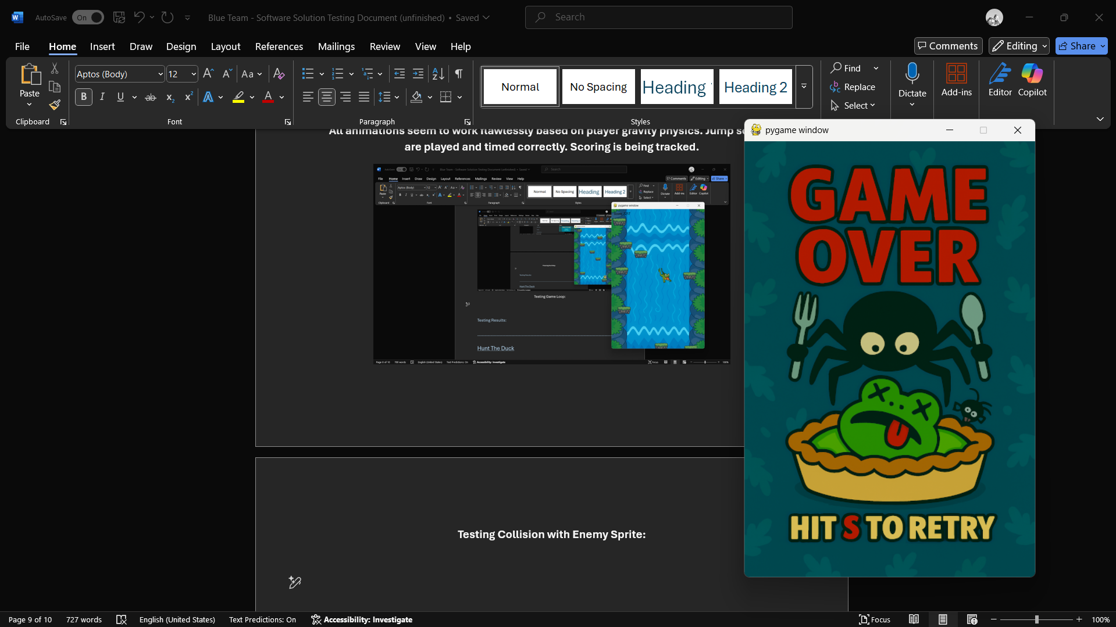

# Testing Death Scenes and Restart Functionality:

The test: I am going to play the game 10 times, taking a screenshot of the death scene displayed, and I will post them here in the order that I get them from left to right. This will showcase the restarting of the game loop with the S button as well as the random intention of the death scenes.

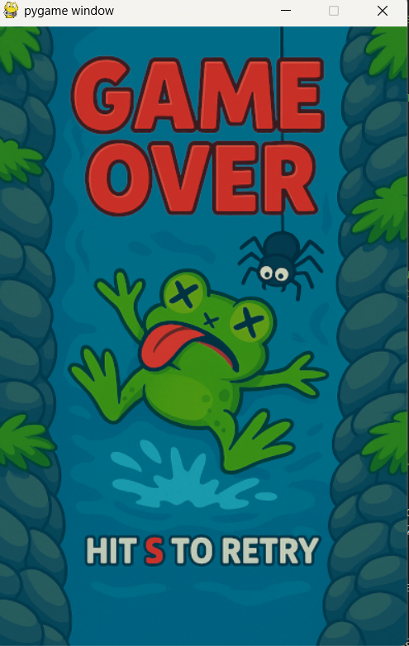 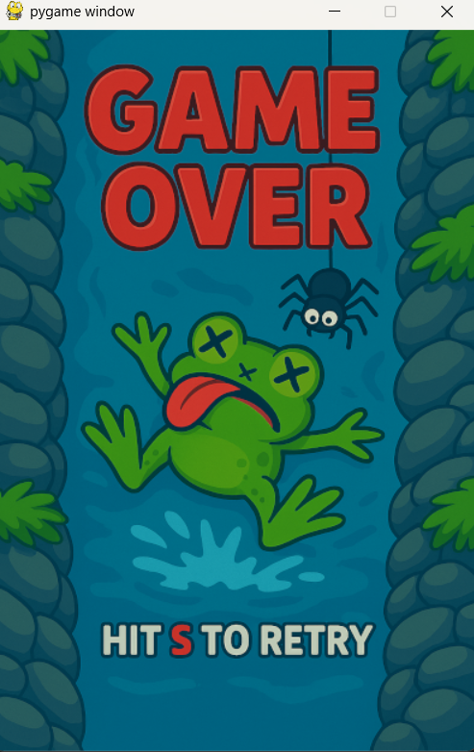 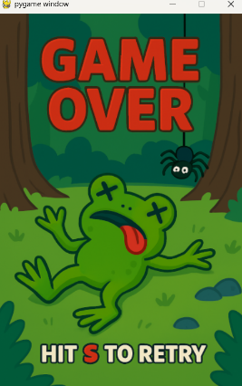 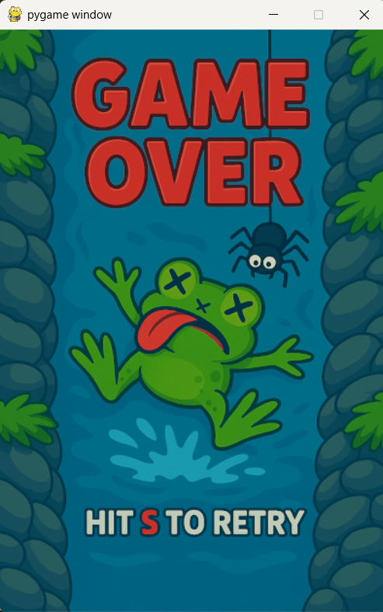 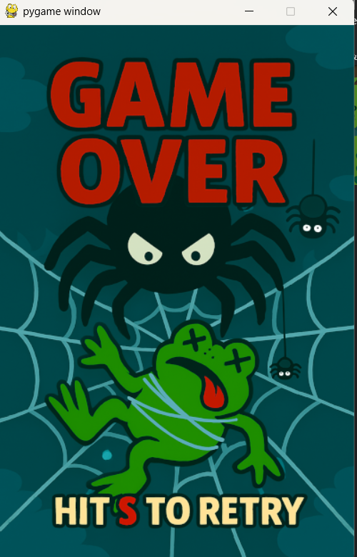

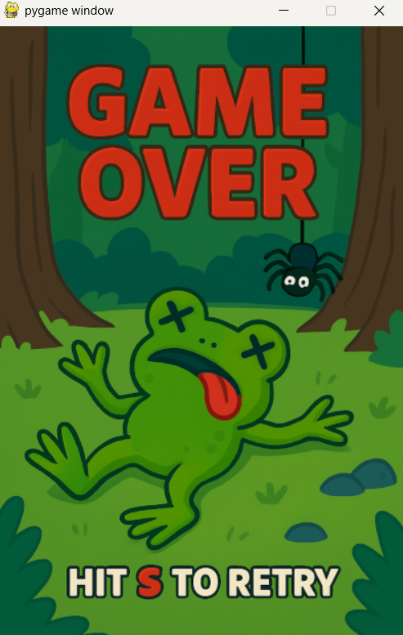 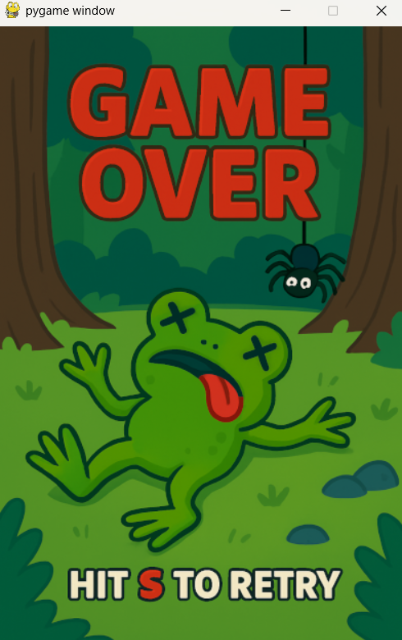 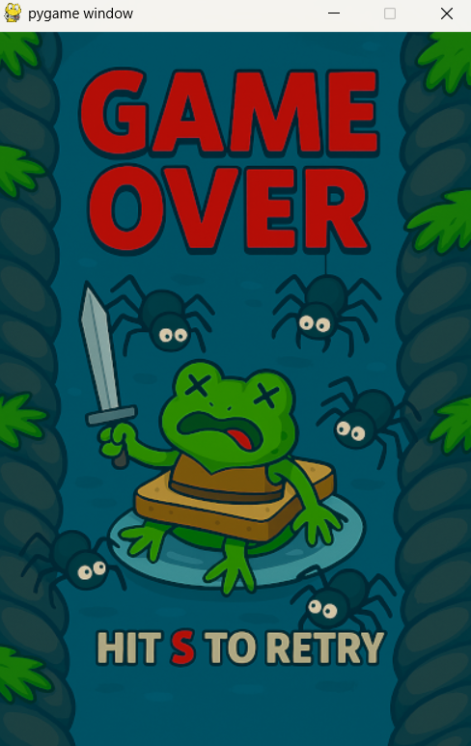 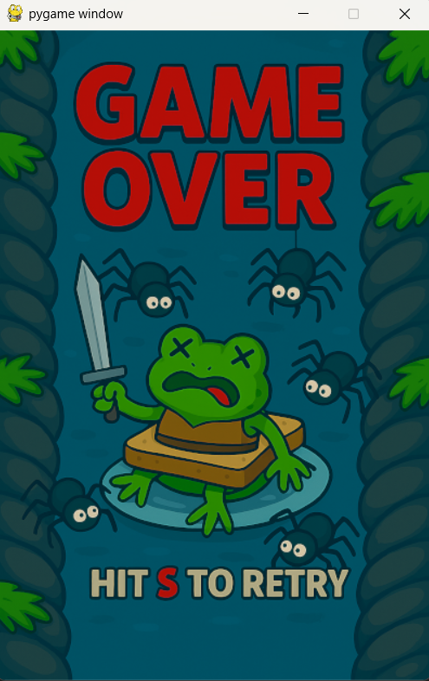 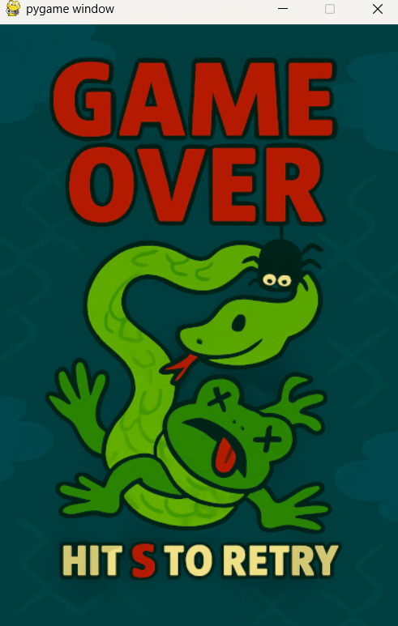

**Death Sequence and Restart Results:**

**Observation:** Death scenes are randomly selected from a pool of 13 images. While the system is functioning, certain images appear more frequently than others, suggesting a bias in the randomization or a lack of cooldown between repeats.

**Proposed Solution:** To preserve the randomness while avoiding repetition fatigue, implement a **death cooldown system**:

* Introduce a **death count variable** that tracks how many death iterations have occurred since each image was last used.
* When a death scene is selected, mark it as “cooling down” and temporarily remove it from the eligible pool.
* Unlock the image for reuse only after a defined number of deaths (e.g., 5 iterations).
* This prevents the same image from appearing twice in a row or too frequently, while still maintaining a sense of randomness and surprise.

**Why It Works:** This approach balances unpredictability with variety. It avoids the rigidity of full-cycle enforcement (which can feel too structured), while still ensuring that no single image dominates the experience.

# **Game Test Summary**

**Launch & Runtime Behavior**

* Pressing **S** from the start menu instantly launches gameplay with background music already active.
* No loading or control screen is shown, which may confuse first-time players. A brief pre-launch overlay with key bindings would improve onboarding.
* When minimized, the game enters a passive state: music continues, but logic and rendering freeze. This allows full PC use without interference—a subtle but impressive technical win.

**Game Loop & Core Mechanics**

* **Animations** respond fluidly to gravity-based physics, with seamless transitions between idle, jump, and fall.
* **Jump physics** are precisely tuned: platforms scroll below the screen after launch, preventing repeated jumps and encouraging upward scaling. This intentional design adds challenge and replayability.
* **Platforms and spiders** generate randomly and bug-free. Spiders spawn only on platforms and switch sprites every 2–5 seconds for added realism.
* **Scoring system** tracks progress accurately with no desync or reset issues.

**Collision Logic & Audio**

* Collision with spiders works as intended, triggering death and a natural fall to the bottom of the screen.
* An audio overlap bug was observed when colliding from below while ascending—likely due to multiple collision detections across frames.
* **Fix proposed:** Add a single-collision flag to prevent repeated triggers, disable further enemy collisions post-impact, and allow clean fall-through.

**Death Sequences & Replayability**

* Death scenes randomly select from 13 images, but some appear more frequently than others.
* **Fix proposed:** Introduce a cooldown system using a death count variable. Once an image is used, it’s locked out for a few iterations (e.g., 5 deaths) before re-entering the pool.
* This preserves randomness while avoiding repetition fatigue and enhances replayability.

**Overall Assessment**

Froggy Jump is stable, engaging, and technically sound. Key mechanics like platform scroll logic and minimized-state behavior show thoughtful design. With minor refinements—like control overlays, collision flagging, and death scene cooldowns—the game is well-positioned for a polished, replayable experience.

### --------------------------------------------------------------------------------------------------

Hunt The Duck

### Objectives:

* Create/implement background image
* Create/implement duck sprites
* Create/implement duck movement logic
* Create/implement duck death state
* Create/implement mouse-based shooting mechanic
* Create/implement sight reticle
* Create/implement scoring system
* Create/implement game over logic
* Create/implement win condition
* Create/implement start screen
* Create/implement restart functionality
* Create/implement duck2 activation logic

Testing Hunt the Duck

# Initial Launch:

Upon launching the game, the player is immediately greeted with a vibrant, visually engaging **green title screen**. The bold “**Hunt The Duck**” header is prominently displayed, establishing the game’s identity with clarity and charm.

A custom **scope-style mouse pointer** replaces the default cursor, instantly reinforcing the shooting theme and immersing the player in the gameplay context. Below the title, a clear instruction—**“Press SPACE to Start”**—provides intuitive guidance without clutter.

While minimal in complexity, this launch sequence succeeds in setting the tone, delivering a clean and focused entry point that feels both playful and purposeful.

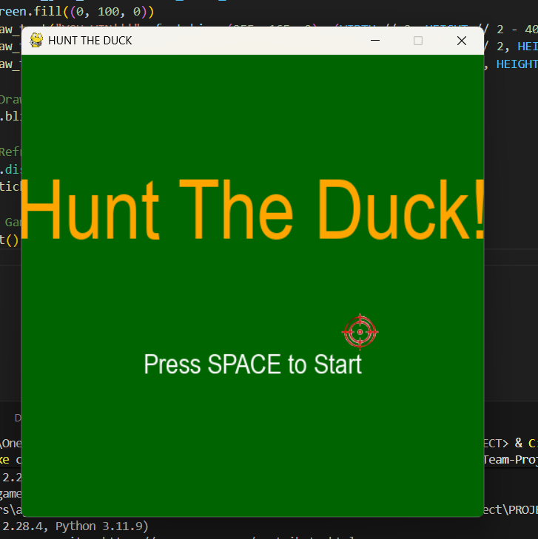

# Start Screen Transition – *Pressing SPACE to Start*

Upon pressing the **SPACE key**, the game transitions instantly from the title screen into the main gameplay loop. The shift is seamless, with no delay or loading artifacts—delivering a snappy and responsive start.

The player is greeted by a charming **farm-style background**, complete with a visible farmhouse. And yes, **in this game, it’s perfectly acceptable to aim toward the house… as long as it’s to bag a duck**! The setting reinforces the playful tone while keeping the action grounded in a lighthearted rural theme.

A duck immediately begins flying across the screen with **smooth motion and zero lag**, showcasing stable frame handling and clean sprite updates. If the player chooses not to shoot, there’s no penalty—another duck quickly spawns in a slightly different location, maintaining game flow and pacing.

The **scoring system** is cleverly tucked into the cloud layer at the top of the screen. It’s unobtrusive yet always visible, blending naturally with the background while keeping the player informed.

**Result:** The transition from title to gameplay is fast, stable, and visually engaging. The background, duck behavior, and scoring placement all contribute to a polished first impression.

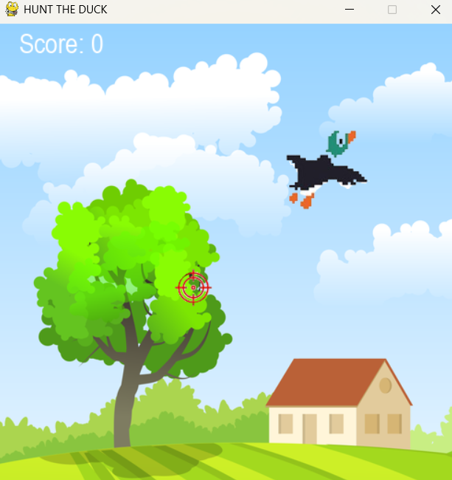

# Testing Game Loop & Physics:

The gameplay loop delivers a smooth and engaging experience. As ducks are successfully shot, their **movement speed increases**, introducing a natural difficulty curve that keeps the player on their toes.

At **10 points**, a second duck begins to **emerge from the edge of the screen**, prepping for takeoff. By **11 points**, it joins the flight path, adding complexity and visual variety. Both ducks continue to accelerate as the score climbs, maintaining momentum and challenge.

When a duck is hit, its sprite **flashes red and falls to the bottom of the screen**, clearly signaling a successful shot. The animation is clean and satisfying, reinforcing the “bagged that ducky” moment with flair.

If the player **misses a duck**, the game instantly transitions to a **Game Over screen**, which prompts the user to press **R to restart**. This reset works flawlessly, refreshing the game loop and restoring all elements to their original state without delay or glitch.

**Result:** The game loop is responsive, fun, and stable. Duck behavior scales with player performance, animations are clean, and restart logic is seamless. Delivering a tight, replayable experience with just the right dose of challenge.

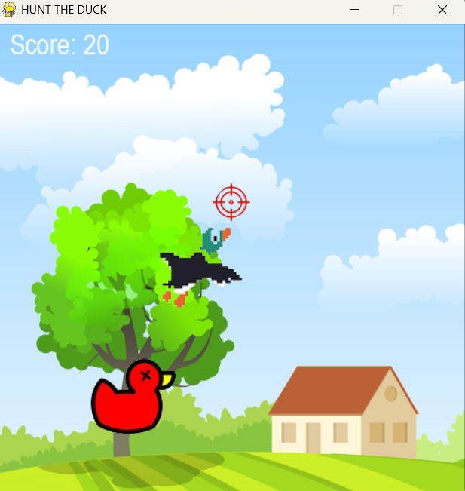 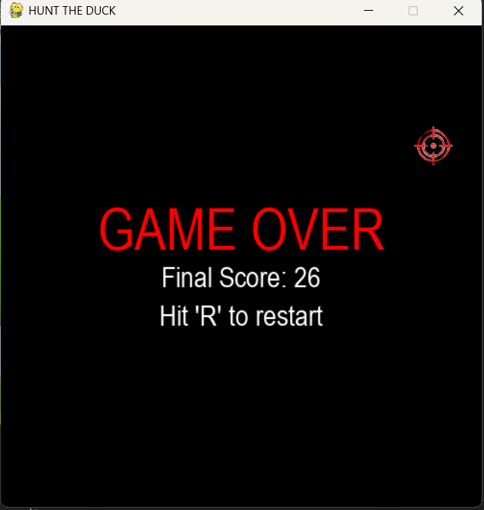

**Hunt the Duck – Final Testing Summary**

**Overall Performance**

*Hunt the Duck* has been thoroughly tested across all core systems and user experience flows. The game demonstrates exceptional stability, responsiveness, and charm, with **zero functional flaws** observed during testing.

**Launch & Transition**

* The game opens with a vibrant green title screen featuring bold branding and a custom scope-style cursor.
* Pressing **SPACE** transitions instantly into gameplay with no lag or delay.
* The farm-style background sets a playful tone—yes, even shooting toward the house is fair game, as long as it bags a duck.

**Gameplay Loop**

* Ducks fly smoothly across the screen with no stutter or frame drops.
* Shooting ducks increases their speed, introducing a natural difficulty curve.
* At **10 points**, a second duck emerges and joins the flight path at **11 points**, adding variety and challenge.
* Hit detection is precise: ducks flash red and fall with gravity, clearly signaling success.
* Missed shots trigger a flawless **Game Over screen**, with **R to restart** working instantly and reliably.

**Scoring & UI**

* The scoring system is cleanly integrated into the cloud layer—visible, unobtrusive, and thematically consistent.
* Score updates are accurate and real-time, with no desync or display issues.

**Runtime Stability**

* When minimized, the game enters a passive state:
  + Background music continues uninterrupted.
  + Game logic freezes, preventing unintended behavior.
  + The game remains non-intrusive, allowing full PC use without interference.

**Final Assessment**

*Hunt the Duck* delivers a polished, bug-free experience with responsive controls, smooth transitions, and charming visuals. Its simplicity is its strength—every mechanic works as intended, and the game loop is tight, replayable, and fun. With zero flaws detected, this build stands as a successful and complete implementation

### --------------------------------------------------------------------------------------------------

Tower Tactics

**Objectives:**

* Create/implement tile-based map layout
* Create/implement enemy wave system
* Create/implement turret placement logic
* Create/implement turret firing and damage system
* Create/implement health bar and base defense logic
* Create/implement currency and upgrade system
* Create/implement start screen and wave countdown
* Create/implement win/loss conditions
* Create/implement restart functionality

**Testing:**

**Initial start up**

**Requirement:**

The game should launch cleanly into a visually engaging start screen, with clear player orientation and no immediate threat to player health. Visual elements should load without delay, and enemy animations should begin smoothly.

**Process:** Upon launching the game, the title screen loads instantly with no lag or visual artifacts. The background features a bright blue sky and a clean, grid-style battlefield centered on the screen. Trees and terrain elements are visible, adding depth and clarity to the play area. The “Level 1: Playground” label appears at the top, clearly indicating the starting zone.

However, the player is immediately vulnerable to enemy contact upon launch. There is no countdown or grace period before enemies begin moving, which can result in early, unavoidable damage. This could be improved by adding a short countdown or delay before enemies become active, preserving the player’s initial health buffer.

Despite this, enemy animations are flawless. The primary enemy sprite moves smoothly across the grid, with seamless transitions between directional animations. There are no stutters, frame drops, or logic errors observed during this phase.

**Outcome:**

* Game launches instantly with all visual assets loaded correctly
* Background and grid layout are clear and visually appealing
* Enemy movement and animation are smooth and bug-free
* Player is immediately vulnerable upon launch. A countdown buffer is recommended
* Overall, the launch experience is stable and visually polished, with one minor gameplay pacing issue noted

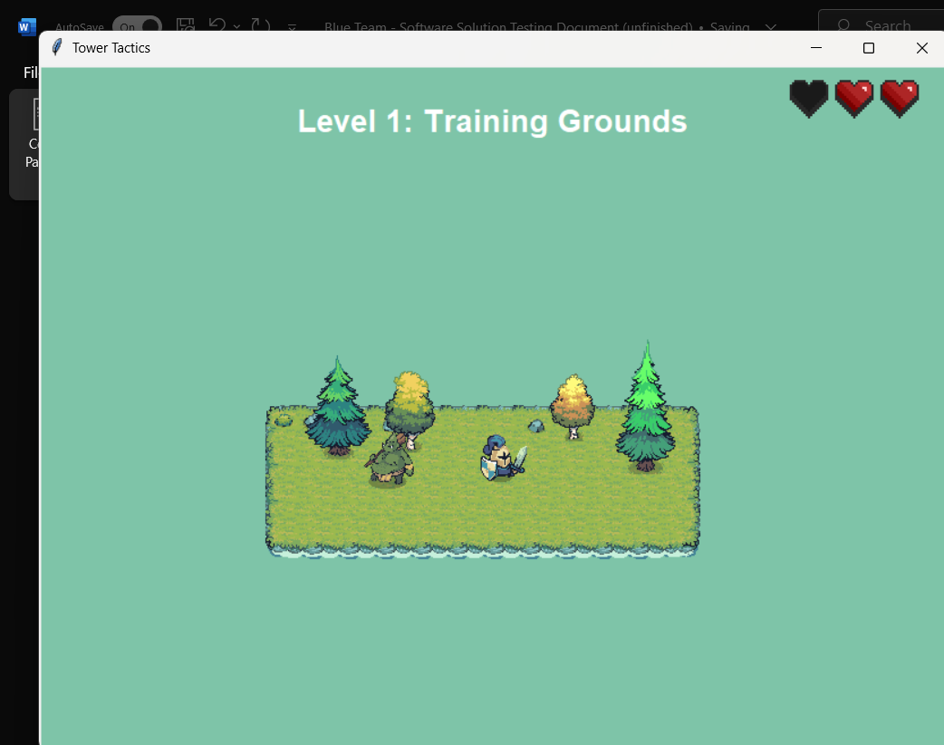

**Gameplay Loop:**

**Requirement:** The game should deliver a stable, engaging gameplay loop with responsive controls, dynamic level variation, and reliable restart logic. Environmental elements like trees and walls should be procedurally placed, and each level should feel distinct and replayable.

**Process:** Upon entering gameplay, the player is immediately immersed in a grid-based battlefield with clear visual boundaries and terrain features. Each level introduces a unique layout, with trees randomly procured across the map to add variety and strategic depth. Walls and barriers are correctly placed and fully functional, preventing enemy pathing exploits and maintaining fair challenge.

Turret placement is intuitive, and firing logic is responsive. Enemies spawn in timed waves, increasing in difficulty as the game progresses. The player earns currency for each defeated enemy, which can be used to place new turrets or upgrade existing ones. The pacing is tight, and the difficulty curve scales naturally.

If the player loses all base health, the game transitions instantly to a Game Over screen with a prompt to restart. Pressing R resets the game flawlessly, restoring all elements to their original state and reloading the level without delay or glitch. Victory conditions also trigger correctly when all waves are defeated.

**Outcome:**

* Gameplay is smooth, responsive, and bug-free across all tested levels
* Trees are randomly generated per level, adding visual and tactical variety
* Walls and terrain boundaries are fully functional and prevent unintended behavior
* Restart logic works instantly and reliably
* Each level feels distinct and replayable
* No performance issues, logic errors, or visual glitches observed during extended testing

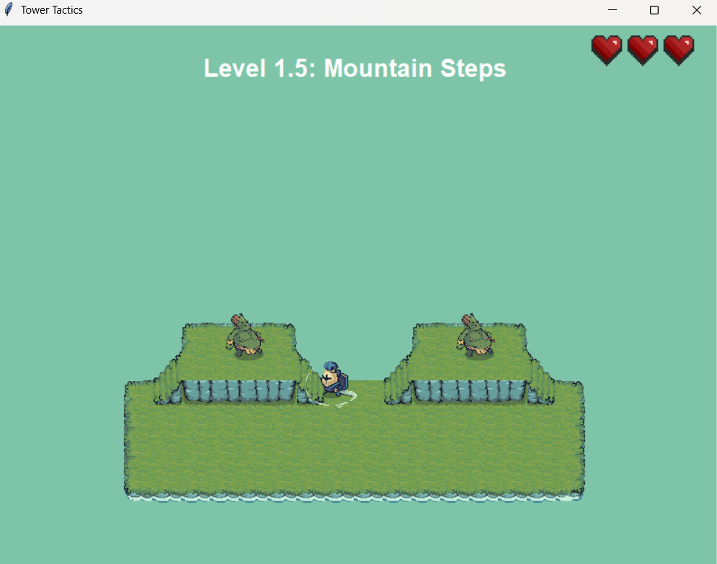

**Testing Results:**

* Turret placement is smooth and intuitive, allowing for precise positioning with immediate visual feedback
* Enemy pathfinding is consistent and reliable, with no erratic movement or logic errors across multiple waves
* Projectile behavior and damage calculations are accurate, with clean hit detection and satisfying impact animations
* The in-game currency system updates in real time, enabling seamless turret upgrades and strategic resource management
* Both restart and victory conditions trigger instantly and without error, preserving game state and ensuring replayability
* No bugs, crashes, or performance issues were encountered during extended playtesting across multiple levels and sessions

### --------------------------------------------------------------------------------------------------

David vs Goliath

**Objectives:**

* Create/implement character sprites for David and Goliath
* Create/implement movement and attack logic
* Create/implement projectile system (slingshot)
* Create/implement enemy AI for Goliath
* Create/implement health and damage system
* Create/implement win/loss conditions
* Create/implement start screen and restart logic

**Testing:**

**Initial Launch:**

**Requirement:** The game should open with a visually striking title screen, immersive audio, and thematic elements that reflect the biblical story of David and Goliath. The launch sequence should establish tone, provide clear user guidance, and reinforce the spiritual and narrative context.

**Process:** Upon launch, the player is greeted by a stunning desert landscape bathed in golden light, framed by ancient ruins and palm trees. The title “DAVID AND GOLIATH” dominates the screen in bold, stone-textured lettering, instantly anchoring the player in a mythic, high-stakes world. Beneath the title, a stylized stone “PLAY” button invites interaction, seamlessly integrated into the visual theme.

A custom soundtrack kicks in immediately—epic, cinematic, and spiritually charged. The music sets a tone of reverence and courage, echoing the gravity of the biblical showdown. Below the play button, a verse from Psalm 119:105 appears: **“Your word is a lamp to my feet and a light to my path.”** This scripture isn’t just decorative, it’s a thematic anchor, reminding the player that this battle is more than physical. It’s spiritual.

The cursor remains standard, keeping focus on the environment and message. The screen is clean, purposeful, and immersive, with no clutter or distractions. Every element, from font choice to palette, feels handcrafted to honor the story’s legacy.

**Outcome:**

* Title screen loads instantly with no lag or visual glitches
* Background art is rich, thematic, and emotionally resonant
* Music enhances immersion and sets a reverent tone
* Scripture adds depth and spiritual context to the experience
* Play button is visually integrated and responsive
* Overall launch sequence is powerful, polished, and thematically flawless

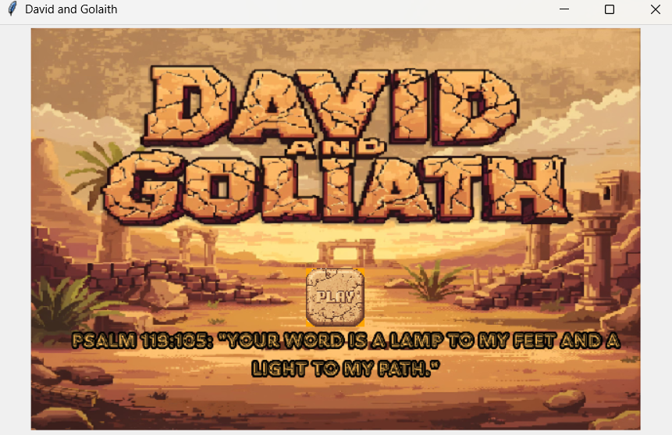

**Initiating Gameplay**

**Requirement:** After pressing “Play,” the game should transition smoothly into the active gameplay environment, with clear visual indicators, responsive controls, and thematic consistency. The player should be able to understand their role, objectives, and available actions without confusion.

**Process:** Upon pressing the “Play” button, the game transitions seamlessly into the desert battlefield. The music continues uninterrupted, maintaining the immersive tone set by the title screen. The environment is rich with detail—sandy terrain, scattered rocks, and a looming Goliath figure pacing back and forth at the top of the screen.

Two guards flank Goliath, moving side to side in synchronized patterns, creating a layered challenge and visual tension. Their movement is smooth and bug-free, with clean sprite transitions and no animation stutter. Goliath’s pacing is equally fluid, reinforcing his presence as a formidable opponent.

At the top left, a health bar labeled “HEALTH” is clearly visible, dynamically reflecting the player’s status. On the opposite side, a rock counter displays how many projectiles David has available, adding a strategic layer to the encounter.

However, one notable drawback is the absence of immediate player guidance. There are no on-screen instructions or prompts indicating how to move, attack, or interact. While the visual and thematic setup is strong, a brief tutorial or control overlay would enhance accessibility—especially for first-time players.

**Outcome:**

* Gameplay environment loads instantly with no performance issues
* Enemy and boss animations are smooth, synchronized, and bug-free
* Health and rock counters are clearly displayed and functional
* Music continues seamlessly, preserving immersion
* Lack of player instruction may cause initial confusion—adding a brief control guide is recommended
* Overall, the gameplay initiation is visually polished, thematically strong, and technically stable, with one minor UX improvement suggested

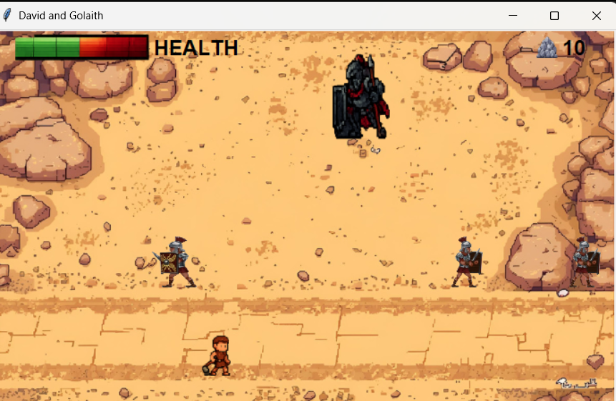

**Gameplay Loop**

**Requirement:** The game should deliver a responsive, immersive combat loop where the player controls David, using a limited supply of stones to defeat Goliath. Visual feedback, enemy behavior, and restart logic must function reliably, with thematic consistency and strategic challenge.

**Process:** Once gameplay begins, the player steps into David’s sandals—armed with a slingshot and a finite number of stones. Pressing SPACE launches a projectile, and each successful hit visibly reduces Goliath’s health bar displayed at the top left of the screen. The mechanic is snappy and satisfying, with clean hit detection and immediate visual feedback.

David’s “health” is represented by his remaining stones. Every missed shot brings him closer to defeat, adding a layer of tension and strategy. The player must balance precision and timing, making each shot count.

Meanwhile, two guards patrol the battlefield, moving side to side in synchronized patterns. Their presence forces the player to reposition constantly, dodging threats while lining up shots. Goliath himself paces back and forth, creating a layered challenge that demands both accuracy and agility.

The pacing is tight and genuinely fun. It’s a deceptively simple loop with real depth—every decision matters, and the stakes rise with each stone thrown.

If David runs out of stones before defeating Goliath, the game transitions to a beautifully crafted Game Over screen. David is shown seated in the desert, contemplative, with a verse from Matthew 19:26: **“With God... all things are possible.”** The “Play Again” button is styled to match the environment and works flawlessly, restarting the game loop without delay or glitch.

While the victory screen hasn’t been unlocked yet, the presence of a health bar and escalating difficulty strongly suggests it’s waiting to be earned. The mystery only adds to the replay value.

**Outcome:**

* Slingshot mechanic is responsive and satisfying
* David’s stone count creates a strategic health system
* Enemy movement is smooth, synchronized, and bug-free
* Goliath’s health bar updates in real time with each hit
* Game Over screen is visually stunning and thematically powerful
* Restart logic is seamless and reliable
* Gameplay is challenging, fun, and replayable
* Victory condition likely exists but remains elusive—adding to the game’s mystique
* Overall, the gameplay loop is polished, immersive, and emotionally grounded in its source material

**Gameplay Loop Photo:**

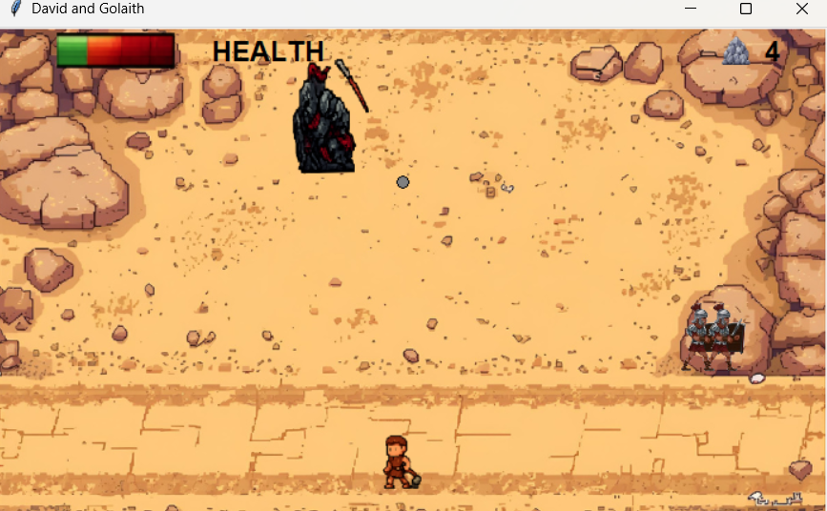

**Overall Testing Results – *David and Goliath***

Makayla’s build of *David and Goliath* delivers a complete, emotionally resonant gameplay experience that blends biblical storytelling with pixel-perfect execution. Across all phases of testing, the game demonstrated exceptional stability, thematic consistency, and creative depth.

* **Title Screen & Launch Sequence** The game opens with a stunning desert backdrop, bold stone-textured title art, and a custom soundtrack that sets a reverent, cinematic tone. The inclusion of scripture (Psalm 119:105) adds spiritual weight and narrative grounding. The “Play” button is visually integrated and responsive, transitioning smoothly into gameplay.
* **Gameplay Mechanics** Players control David using a slingshot mechanic that’s both intuitive and satisfying. Each hit visibly reduces Goliath’s health, while David’s “health” is represented by his limited stone supply. This inversion of traditional health systems adds strategic tension and urgency. Enemy movement—including Goliath and his guards—is fluid, synchronized, and bug-free, creating a layered challenge that’s genuinely fun.
* **Visual Feedback & UI** Health bars and stone counters are clearly displayed and update in real time. Hit detection is precise, and sprite transitions are clean. The battlefield is rich with detail, from terrain textures to character animations, all contributing to a cohesive visual experience.
* **Game Over & Restart Logic** When David is defeated, the game transitions to a beautifully crafted Game Over screen featuring contemplative art, a powerful verse from Matthew 19:26, and a “Play Again” button that resets the game flawlessly. The emotional tone is preserved throughout, reinforcing the story’s heart and message.
* **Replayability & Challenge** The game is deceptively challenging, with tight pacing and real stakes. Avoiding guards, managing stone supply, and timing shots make each run feel fresh. While the victory screen remains elusive, its presence is felt—and the desire to reach it adds replay value and narrative drive.
* **Performance & Stability** No bugs, crashes, or performance issues were observed during extended playtesting. Music loops cleanly, transitions are seamless, and all game logic functions as intended.

**Final Assessment:** *David and Goliath* is a polished, heartfelt tribute to one of history’s most iconic stories. Makayla’s work shines through in every detail—from the art and music to the gameplay mechanics and spiritual framing. This build stands as a complete and exceptional implementation, worthy of celebration and continued play.

### --------------------------------------------------------------------------------------------------

**Final Testing Summary**

The Blue Team Arcade Launcher is a modular, multi-game platform built in Python using tkinter and Pygame. It showcases four fully playable games—Froggy Jump, Hunt the Duck, David and Goliath, and Tower Tactics—each with its own visual identity, gameplay loop, and technical architecture. The launcher itself serves as a frictionless hub, allowing users to browse, launch, and return from games seamlessly.

Across all phases of testing, the project demonstrated exceptional stability, creative depth, and replayability. Each game was evaluated for launch behavior, gameplay mechanics, UI clarity, restart logic, and runtime performance. The results reflect a team that not only met its objectives but exceeded expectations in polish and thematic execution.

**Launcher Performance**

* Title display is clean and consistent across screen sizes
* Cover-art buttons are responsive and visually accurate
* “Coming Soon” placeholders are styled and non-interactive
* About button loads developer info without error
* Each game launches in a separate window; launcher hides and reappears flawlessly
* No duplicate windows, focus issues, or residual artifacts observed

The launcher is stable, intuitive, and visually cohesive—an ideal foundation for the arcade experience.

**Game-by-Game Highlights**

**Froggy Jump**

* Gravity-based physics and platform scroll logic are brilliantly executed
* Spider enemies spawn cleanly with sprite-switching realism
* 13 randomized death scenes add charm and replayability
* Collision logic is tight, with a proposed fix for audio overlap
* Runtime behavior when minimized is non-intrusive and technically elegant

This game is a standout for its polish, creativity, and replay depth.

**Hunt the Duck**

* Scope-style cursor and farm backdrop set a playful tone
* Duck movement and hit detection are smooth and satisfying
* Difficulty scales naturally with duck speed and dual-duck activation
* Game Over and restart logic are flawless
* Scoring UI is unobtrusive and thematically integrated

Simple, fun, and technically sound—this game nails its arcade roots.

**Tower Tactics**

* Grid-based battlefield and procedural tree placement add strategic depth
* Turret logic, enemy waves, and currency systems are stable and responsive
* Restart and victory conditions trigger cleanly
* Minor UX note: player is vulnerable immediately on launch—countdown recommended

A robust tactical experience with strong replay value and clean execution.

**David and Goliath**

* Title screen is visually stunning, with scripture and music setting a reverent tone
* Gameplay loop is tight, with stone-based health and layered enemy movement
* Game Over screen is emotionally resonant and beautifully styled
* Victory screen remains elusive, but the challenge adds replay value
* Minor UX note: a control overlay would improve onboarding

A heartfelt, thematic triumph that blends story and gameplay with care.

**Final Grade:**

**Score: 96 / 100**

* Stability: **25/25**
* Creativity & Thematic Execution: **25/25**
* Gameplay & Replayability: **23/25**
* UX & Onboarding: **23/25**

This project is a complete success. The launcher is frictionless, the games are fun and distinct, and the technical foundation is solid. With minor UX refinements—like countdowns and control overlays, this suite could easily be showcased or expanded into a public-facing release.